REGISTRATION FORM

SPECIAL EDUCATION:
How to Navigate IEP / 504 / Transition Plans and
Advocate to Get What Your Student Needs

This training is funded by the WV Developmental Disabilities Council

Thursday, June 8 8:30 am – 3:00 pm (Doors open at 8:00 am)
Holiday Inn Express Conference Room
941 WV-34, Hurricane, WV 25526

First Name* Last Name*
Email Address * Phone *
Agency or Organization (if applicable)
Street Address Address 2
City State Zip/Postal Code
Please select the choice that best describes you *
I am a person with a disability
I am a parent/guardian
I am a service provider or agency staff
I am an educator, administrator, or school support personnel
I am a professional/practitioner who provides a service in the community
Other

Please select one
My student is currently receiving special education services
My student may need special education services and I am seeking information on how to proceed

Grade category of my student(s) *
Not in school yet 3 years – Kindergarten Elementary School Middle School High School

Do you require materials be made available in an alternate format? If so, please explain.

This fillable form can be downloaded, completed, and emailed to christina.smith@astrive.org or dropped off at the Wood County Society office at the above address.
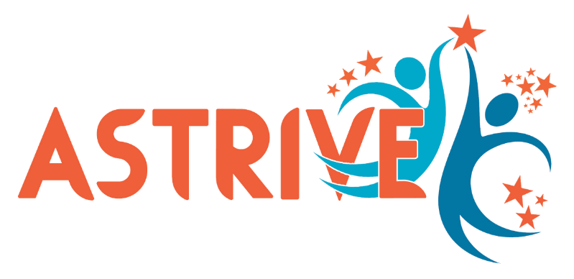
Astrive Advocacy, Inc.
www.astrive.org / christina.smith@astrive.org
www.facebook.com/astriveadvocacy

This project was made possible by funding from the WV Developmental Disabilities Council and supported in part by a grant from the U.S. Administration from Community Living (ACL), Department of Health and Human Services, Washington, D.C. 20201.

